Press Release
5 July 2022, for immediate release:

New exhibition:
WASTE LAND
Industrial Waste Exposed
5 July–20 November 2022

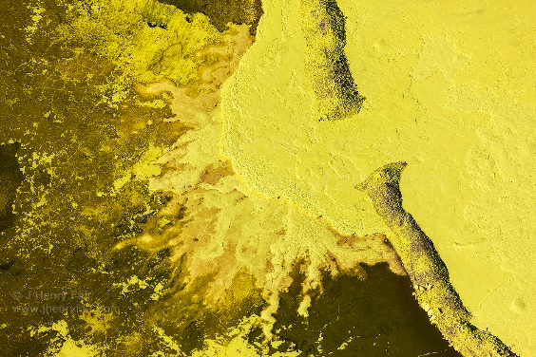  Air Pollution: Sulphur Waste Pit at Oil Refinery  Baton Rouge, Louisiana, USA  © J Henry Fair, 2022 | The Museum of Natural History presents a new exhibition of spectacular photos by acclaimed American photographer, J Henry Fair (b. 1959). Waste Land displays 13 panoramic aerial photos of environments dramatically altered by the effects of climate change, pollution and manmade catastrophes. Capturing the electric colours and patterns of vast landscapes, extreme temperatures and awesome scale, the photos simultaneously resemble masterful abstract paintings and reveal the terrible extent of the damage being inflicted on the earth.
J Henry Fair is a renowned environmental activist and photographer. He was the 2019 Environmental Photographer of the Year and in 2020 he was included in Human Nature, a volume of work by 12 of the world’s most influential nature photographers. He uses large-scale aerial photography – a medium uniquely well-matched to his subject – to create breath-taking images of environmental disasters and the destruction of nature. His work has captured notorious events like the Deep Water Horizon oil spill (2010); lakes and rivers luminous with chemical pollution; and the scars inflicted on the land by logging and fracking. His portfolio represents a devastating record of our impact on the earth.
Highlights of the exhibition include a landscape surrounding a coal-fired power plant in South Carolina. What could be mistaken for a painterly experiment with colour, is in fact the effect of industrial contaminants – arsenic, lead, mercury and selenium – born in coal-ash, infecting the ground and local bodies of water. Another scene, resembling the topography of an alien planet, is in fact the sulphur pit of an oil refinery where the waste product has turned the land a supernatural shade of yellow.

J Henry Fair says: ‘Throughout my career I’ve attempted to document the ever increasing damage that voracious consumption is inflicting on the planet. Aerial photography allows the distance and perspective required to capture the scarcely believable scale of this damage. I hope these images of inadvertently beautiful landscapes show people the tangible harm we are doing, how close we are to environmental disaster, and ultimately how much we have to lose or save.’

Professor Paul Smith, Director of the Museum says: ‘Our Contemporary Science & Society exhibitions present the work of contemporary artists and scientific researchers on subjects of societal relevance. We aim to engage our audiences with the natural wonders of the world and the most pressing issues faced by the planet.

‘J Henry Fair’s extraordinary images demonstrate the shocking extent of climate change and the destruction caused by consumption of fossil fuels and natural resources. I hope they allow people to reflect on the huge impact that small, personal changes could make for the planet and the future.’
View the exhibition online: https://oumnh.web.ox.ac.uk/waste-land

---ENDS---

Press Images
Images for editorial use are available to download at on request.
Contact details
Claire Parris, Press Manager, Oxford University Museums and Garden
claire.parris@glam.ox.ac.uk / 07833 384 512

Notes to editors

Exhibition Waste Land: Industrial Waste Exposed
Dates 5 July–20 November 2022, open daily 10:00–17:00
Venue Upper Gallery, Oxford University Museum of Natural History, Parks Road, Oxford OX1 3PW
Admission Free

J Henry Fair (b. 1959, South Carolina, USA) is an award winning photographer and environmental activist. With studios in New York and Berlin, his work has been exhibited at galleries across the world and included in critically acclaimed group and monograph publications. He is the recipient of the 2012 Earth Through a Lens Award and was named the 2019 Environmental Photographer of the Year.
As an activist, he is the co-founder of the Wolf Conservation Centre, Salem, NY; and he has collaborated with the Natural Resources Defense Council, the Rainforest Alliance, and the Open Space Institute. Visit: www.jhenryfair.com

Oxford University Museum of Natural History was established in 1860 to draw together scientific studies from across the University of Oxford. Home to 7 million objects including 30,000 zoological specimens, the Museum continues to be a place of scientific research, collecting and fieldwork, and hosts a programme of events, exhibitions and activities for the public and students of all ages. Highlights of the collections include the world's first scientifically described dinosaur – Megalosaurus bucklandii – and the world-famous Oxford Dodo, the only soft-tissue remains of the extinct dodo. Admission to the Museum is free.

